Project Performance Test

Date | 04 July 2026
Team ID | SWTID-2026-5158
Project Name | India's Agricultural Crop production Analysis
Maximum Marks

Model Performance Testing:
Project team shall fill the following information in model performance testing template.
S.No. | Parameter | Screenshot / Values
 | Data Rendered | Dataset successfully connected and rendered in Tableau. Dataset contains 345,408 rows and 10 columns covering agricultural production data from 1997–2021.  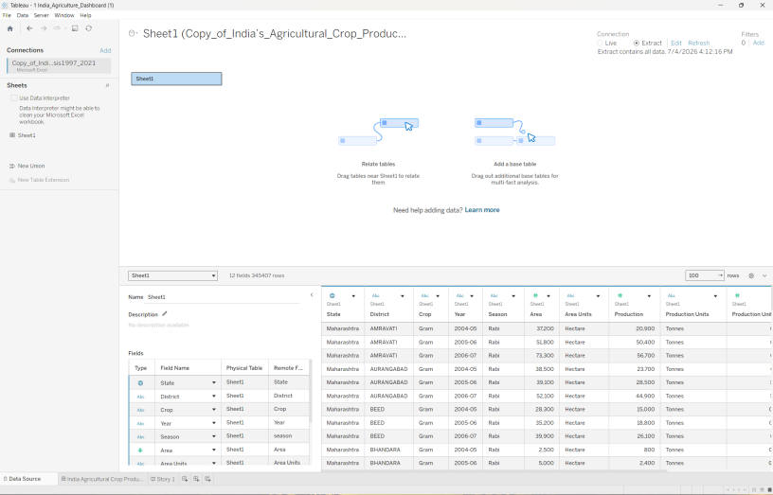
 | Data Preprocessing | Connected dataset to Tableau, verified data types, organized dimensions and measures, and created a calculated field named Production Efficiency (SUM([Production]) / SUM([Area]))  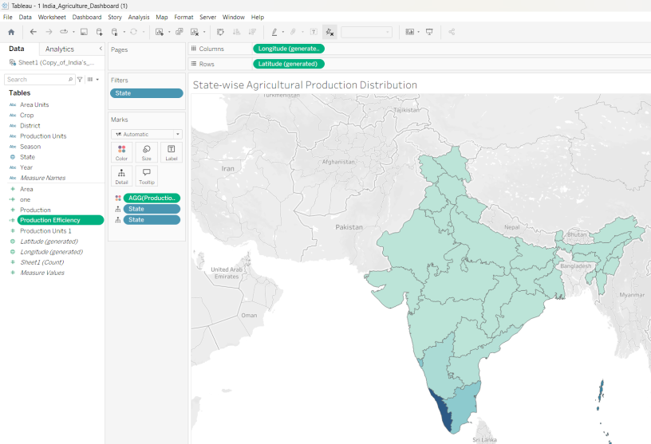
3. | Utilization of Filters | Implemented interactive dashboard filters: State Filter, Crop Filter, and Production Range Filter. Applied filters to all worksheets using the same data source. 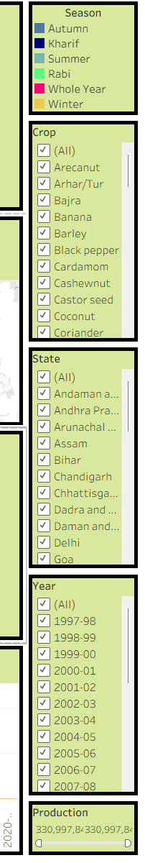
4. | Calculation fields Used | 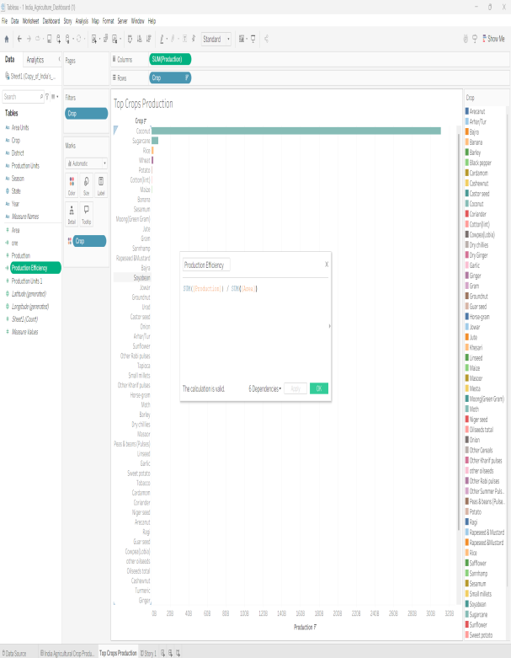  Production Efficiency = SUM([Production]) / SUM([Area])
5. | Dashboard design | No of Visualizations / Graphs –  They are:  • KPI – Total Production  • KPI – Total Yield  • Agricultural Yield Trend (Line Chart)  • India Production Map  • Crop-wise Total Production Analysis (Horizontal Bar Chart)  • State-wise Cultivated Area Comparison (Grouped Bar Chart)  • Leading States by Agricultural Production (Bar Chart)  • Year-wise Total Agricultural Production (Bar Chart)  • Production Distribution by Unit Type (Donut Chart)  • Season-wise Agricultural Production Share (Pie Chart)  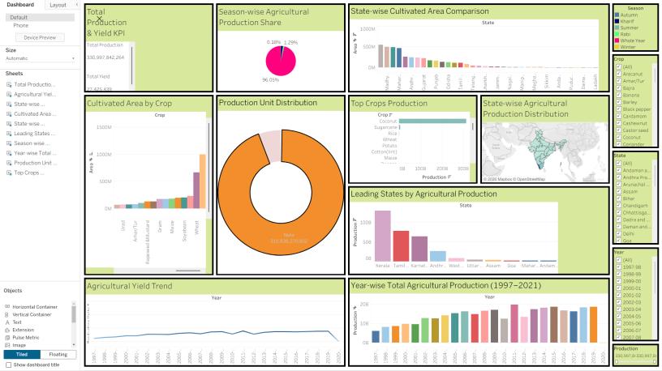
6 | Story Design | No of Visualizations / Graphs –  - India Agriculture Overview  2. Geographic Distribution  3. Crop and State Performance Analysis  4. Seasonal Production Patterns  5. Agricultural Growth Trends (1997–2021)  